## Part 1 – Select the right answer

Top of Form

1. What type of query gets information from a database?

 SELECT

 UPDATE

 GET

 RETRIEVE

2. What type of query removes information from a database?

 REMOVE

 DELETE

 SUBTRACT

 ELIMINATE

3. What type of query can change content in a database?

 REMOVE

 MODIFY

 ADD

 UPDATE

4. What type of query can add new information into the database?

 ADD

 ADJUST

 APPEND

 INSERT

5. In the query “SELECT address FROM users”, what is the column being selected?

 SELECT

 address

 FROM

 users

6. What is the keyword you would use before adding conditions to your query?

 WHAT

 WHERE

 EQUALS

 CONDITIONS:

7. What keyword wraps the data that you would like to insert in an INSERT query?

 DATA()

 RAWDATA()

 VALUES()

 VALUE()

8. What is the keyword you would use in an UPDATE query to modify the existing value?

 EDIT

 SET

 MAKE

 WRITE

9. If you want to apply a second condition to your statement where both statements must be true, what keyword would you use between the conditions?

 AND

 BOTH

 TRUE

 WHERE

10. To sort your results by a column name, what keyword would you use before the column name?

 ORDER BY

 SORT BY

 BY

 IF

11. What keyword would you use to group your results by a column’s values?

 ORDER BY

 GROUP BY

 BY

 JOIN

12. When sorting your results by a column’s values that are integers, what keyword would you use to sort from greatest to least?

 ASC

 DSC

 DESC

 AESC

13. If you are only retrieving one column’s values, what keyword can you add before the column name to only return unique values?

 UNIQUE

 DISTINCT

 ONE

 SINGLE

14. What keyword can you use to search for a string in a column?

 FIND STRING

 HAS STRING

 CONTAINS STRING

 LIKE

15. What keyword can you use to merge two tables based on a matching column?

 JOIN

 MERGE

 ATTACH

 AND

16. What function can you use to add all of a column’s values together?

 ADD

 EQUALS

 SUM

 SUMMED

17. What function would you use to return the highest value of a column?

 PEAK

 HIGH

 MAX

 TOP

18. What function can you use to compare dates?

 DATEDIFF

 DATECOMPARE

 DATE SUBTRACT

 DATE DIFFERENCE

19. What function would you use to round all values up?

 ROUND UP

 ROUND MAX

 MAX

 CEILING

20. What function would you use to round all numbers down?

 FLOOR

 ROUND DOWN

 ROUND MIN

 MIN

## Part 2 – Please write down your SQL and result

**Table 1** − CUSTOMERS Table

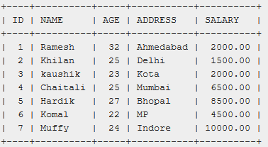

**Table 2** − ORDERS Table

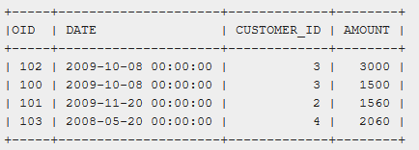

Query 1: List the customer whose age is between 20 to 25.

SELECT NAME FROM CUSTOMERS

WHERE AGE >= 20 AND AGE <= 25;

Query 2: List the customer whose name starts with ‘K’.

SELECT NAME FROM CUSTOMERS

WHERE NAME LIKE 'K%';

Query 3: List the customer whose name not start with C,H,M characters.

SELECT NAME FROM CUSTOMERS

WHERE LEFT(NAME, 1) NOT IN ('C', 'H', 'M');

Query 4: What is the query to fetch the first record from Customer Table?

SELECT NAME FROM CUSTOMERS

LIMIT 1;

Query 5: Which customer’s order amount exceeds his/her salary?

SELECT NAME FROM (

    SELECT NAME, SUM(SALARY) SUM_SAL, SUM(AMOUNT) SUM_AM FROM

        CUSTOMERS C LEFT JOIN ORDERS O ON C.ID = O.CUSTOMER_ID

    GROUP BY C.ID

    HAVING SUM_AM > SUM_SAL) T;

Query 6: List the customer who never place an order.

SELECT DISTINCT NAME FROM CUSTOMERS

WHERE ID NOT IN (

    SELECT DISTINCT CUSTOMER_ID FROM ORDERS

);

Query 7: List customer’s first order date.Bottom of Form

SELECT NAME, MIN(DATE) FROM

    CUSTOMERS C LEFT JOIN ORDERS O ON C.ID = O.CUSTOMER_ID

GROUP BY C.ID